**Project: - Automated Applications**

**Name: - Yadwinder Singh Cheema (100380980)**

**Harninder Kaur (100369777)**

**Pritpal Singh (100374122)**

**Course: - INFO1113 S10**

**Instructor: - Abhijit Sen**

**Date: - 28, November 2019**

**Emails:** [-yadwinder.cheema@email.kpu.ca](mailto:-yadwinder.cheema@email.kpu.ca)

[harninderkaur@email.kpu.ca](mailto:harninderkaur@email.kpu.ca)

[spritpal130@yahoo.com](mailto:spritpal130@yahoo.com)

**Websites URL: -** <https://sites.google.com/view/developingtechnology/home>

<https://sites.google.com/view/harninder/file-cabinet>

<https://sites.google.com/view/pritpal/home>

**TABLE OF CONTENTS: -**

**Contents**

1.SUMMARY: - 3

2.INTRODUCTION: - 3

3.Functional and Non Functional description 4

4.Use-case Diagram: - 6

5.Use-Case Descriptions 7

6.Class Diagram: - 11

7.One sequence Diagram: - 12

8.Interface Prototype: - 13

9.Access database: - 18

**9.a Tables 18**

**9.b Queries: 20**

10.Trellos link 22

11.Project Experience 23

12.Conclusion 24

13.Work Cited 25

# **1.SUMMARY: -**

Automated application is a vital part of the development process for building robust software. Deep learning started to perform tasks that were impossible to do with classic rule-based programming. Fields such as speech and face recognition, image classification and natural language processing. Much like flossing and filing your taxes on time, automated is an area of a developer's life that should not be avoided. Many of the same questions have come to the fore again today, as a result of remarkable recent advances in technologies including robotics, artificial intelligence (AI), and machine learning. Automation now has the potential to change the daily work activities of everyone, from miners and landscape gardeners to commercial bankers, fashion designers, welders—and CEOs.

# **2.INTRODUCTION: -**

Machine Learning is a part of AI that learns from the data that also involves the information gathered from the previous experiences and allows the computer program to change its behavior accordingly. In the technology domain, the impact of automation is increasing rapidly, both in the software/hardware and machine layer. The basic premise of automated application is to build algorithms that can receive input data and use statistical analysis to predict an output while updating outputs as new data becomes available. This application is a field of study that gives computers the ability to learn without being explicitly programmed. It explores the study and construction of algorithms that can learn from and make predictions on data.

# **3.Functional and Non Functional description**

**Functional Requirements**

Is how the product works, such as a computer works with a hardware, assembled with inputs and outputs such as the keyboard, mouse, etc.

**Non-Functional Requirements**

The non-functional requirements are the characteristics of the functional requirements, such as there is a process for the computer, it is interpreted by taking instructions from how data is entered and perceived through the hardware.

The following table below shows the relationship between functional and non-functional requirements.

**Functional Requirements**                                    **Non-Functional Requirements**

* Connection                                                 - Speed ex. Lan network
* Capacity                                                     - Storage ex. GB, MG, RAMS
* Hardware                                                   - Software

The hardware are the components such as the CPU (central processing unit), keyboard, mouse, printer, anything that is visible on sight, and for the software “it’s an invisible component of a computer system that makes it possible for you to interact with the computer's physical components (Crucial).” They both are related to one another where it takes instructions from the software to interpret into the hardware. As stated according to a source which explains how software and hardware are related, “Although a computer can function only when both hardware and software are working together, the speed of a system will largely rely on the hardware used (Ballew, Lifeware)”.

Another example, of a software is Windows operating system which is “preinstalled on Windows computers. It’s what lets you interact with the physical computer system. Without this software you wouldn’t’t be able to start up your computer, get into Windows, and access the Desktop (Ballew, Lifeware)”. This is another example of how functional and non-functional requirements is used together.

# **4.Use-case Diagram: -**

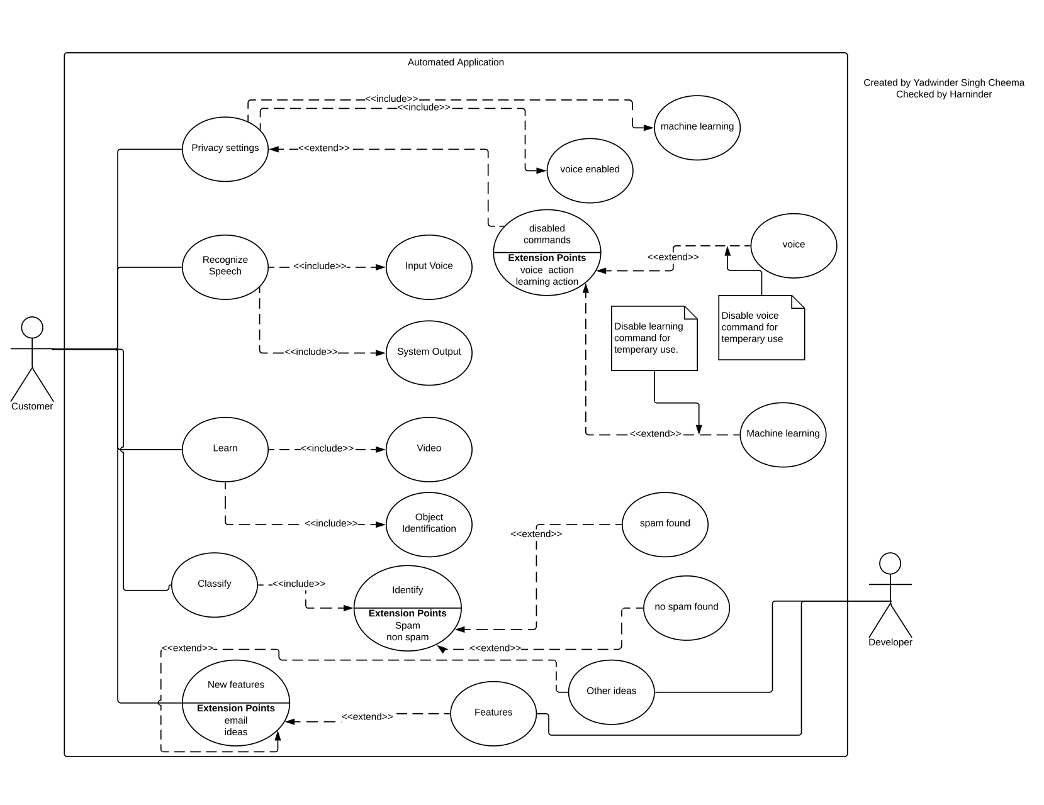

# **5.Use-Case Descriptions**

**Yadwinder:**

|  |
| --- |
| Use Case Title : Speech Recognition |
| Primary Actor : Customer |
| Level: Blue (Sea level view) |
| Stakeholder: Customer |
| Preconditions: User have to have a micro-phone and a speaker enabled and they have to download the stand alone application. |
| Minimum Guarantee: It will give back and random output with no relation to conversation. |
| Success Guarantee: It will correspond to all topics automatically and will take part in all conversations unless disabled. |
| Trigger: Any conversation during turned on microphone will enable this feature to work |
| Main Success Scenario:  1) Customer will install required extensions and hardware’s on device.  2) Customer will open command list and remember it.  3) Customer will try talking to system.  4) Customer will command “Disable Feature/Application name” to disable feature.  5) Customer will command “Enable Feature/Application name” to enable it back.  6) Customer will use “Retrieve” command to continue previous conversation. |
| Extensions:  1.a Provide random output.  1.a.1. Will Show error message on screen.  1.a.2. Will ask user to start Diagnostic scan.  1.b Not recognize proper voice commands  1.b.1. Will Input wrong or partial value.  1.b.2. Check all hardware requirements.  1.c.3. Diagnose the defective device.  1.c No commands working.  1.c.1. Show message for missing file extension.  1.c.2. Give detailed steps to correct error. |

**Harninder:**

|  |
| --- |
| Use Case Title: Classification |
| Primary Actor: Customer |
| Level: Blue (Sea level view) |
| Stakeholders: Customer, Developer |
| Preconditions: This is an application that needs to be downloaded and install to use its features as standalone application. |
| Minimal Guarantee: A user who enters correct credentials gets into the system. If the credentials are incorrect, access is denied, and an error message is displayed. |
| Success Guarantee: If the user logs in successfully if the credentials entered are correct, the input (data, clicks, etc.) that we provide will cause the application to be a certain way and generate a certain output. |
| Trigger: Make your device automatically change settings like Bluetooth, Wi-Fi, or perform actions like sending SMS, e-mail, based on your location, the time of day, or any other “event trigger”. You can automate almost everything on your device. |
| Main Success Scenario:  1) A marketing mail would go to that folder.  2) An email about work would come into my primary inbox (and so on). This would make life so much easier.  3) Gmail also uses machine learning to figure out if the email is spam or not.  4) This is where getting more data for a machine learning algorithm is so helpful – something Google has in abundance. |
| Extensions:  1.a. Data Acquisition:  1.a.1. requires massive data sets to train on, and these should be inclusive/unbiased, and of good quality.  1.a.2. can also be times where they must wait for new data to be generated.  1.b. Time and Resources:  1.b.1. needs enough time to let the algorithms learn  1.b.2. develop enough to fulfill their purpose with a considerable amount of accuracy and relevancy. |

**Pritpal**

|  |
| --- |
| Use Case Title : Learning |
| Primary Actor : Customer |
| Level : Blue (Sea level view) |
| Stakeholder : Customer |
| Preconditions: User need system and speaker to see video. May require high speed internet to download video. |
| Minimum Guarantee: It will give you an idea about what speech recognition can do and teach you how to use it. |
| Success Guarantee: It will show the software orientation every time you click on it |
| Trigger: when you click on learning on side bar it will start showing you videos |
| Main Success Scenario:  1) Customer will install required system and hardware on device to run it.  2) Customer will open web page.  3) Customer will click on learning option in side bar.  4) Customer will have to find what video and object he is looking for. |

# **6.Class Diagram: -**

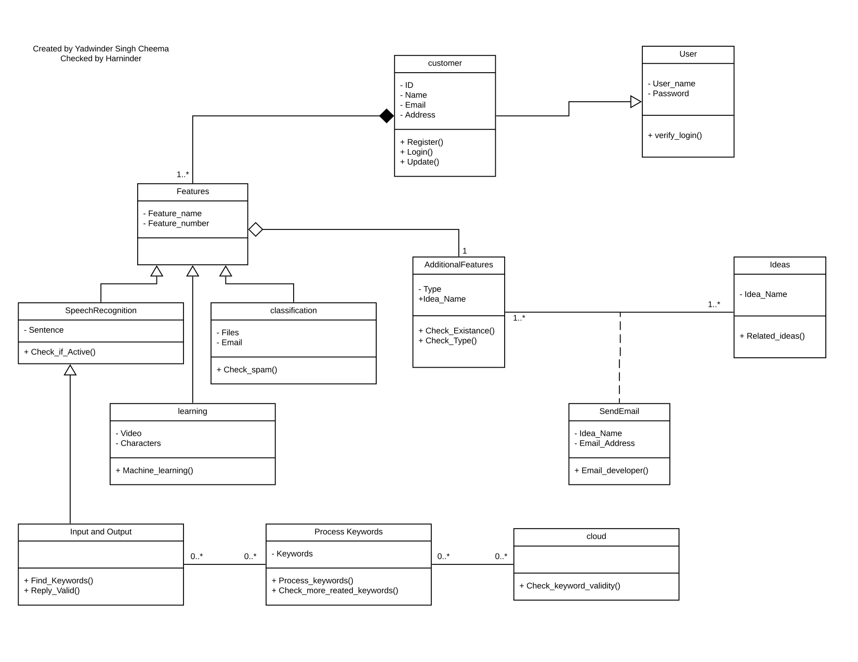

# **7.One sequence Diagram: -**

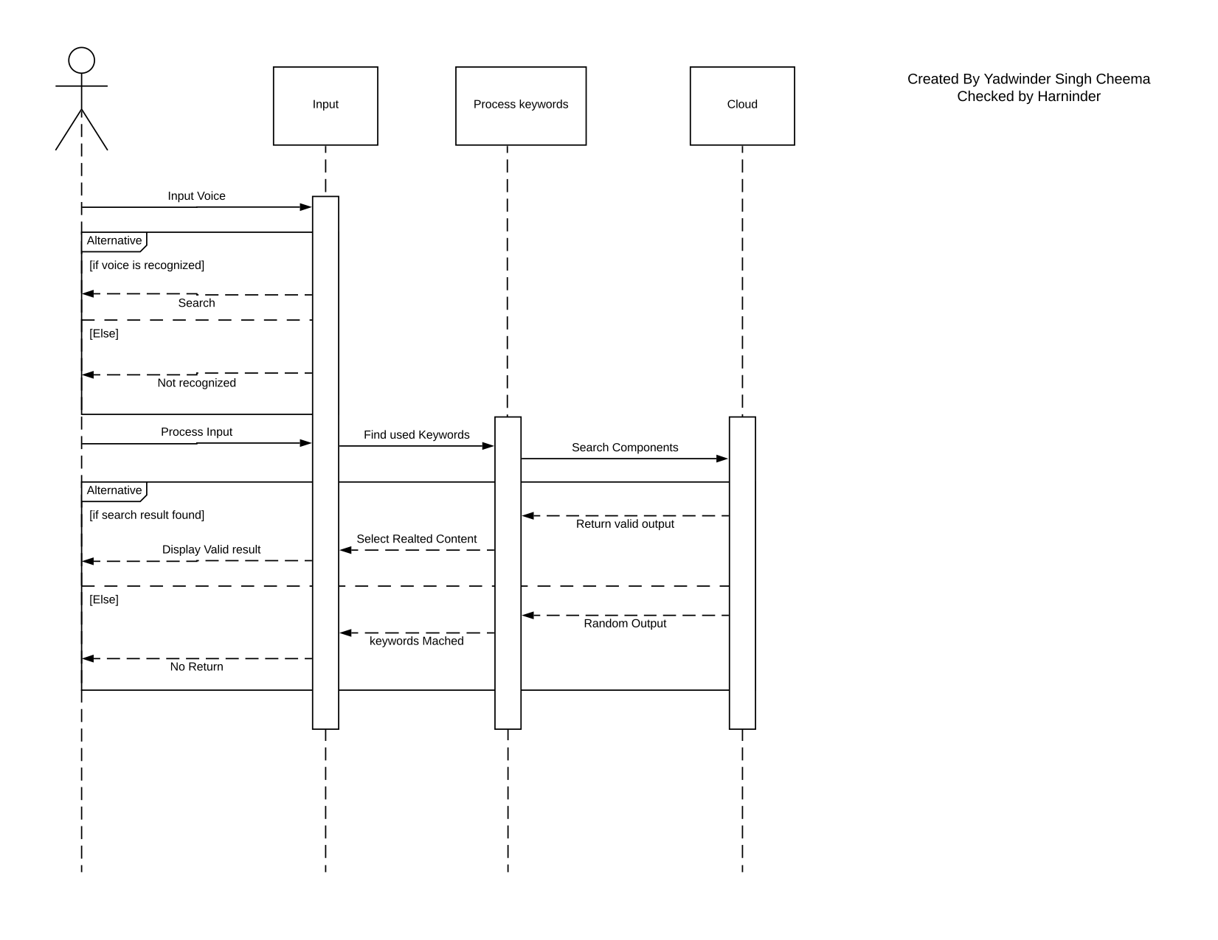

# **8.Interface Prototype: -**

Created by: - Pritpal

Checked by: - Yadwinder Singh Cheema

**Recognize speech**

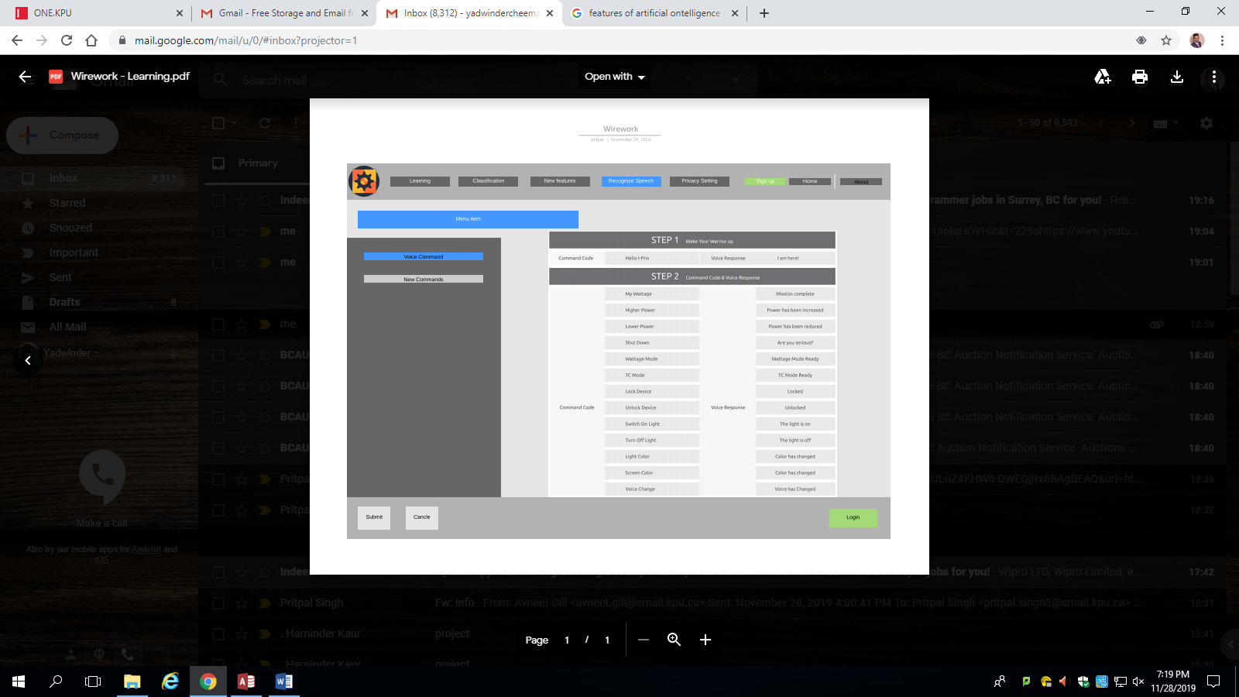

**Privacy settings**

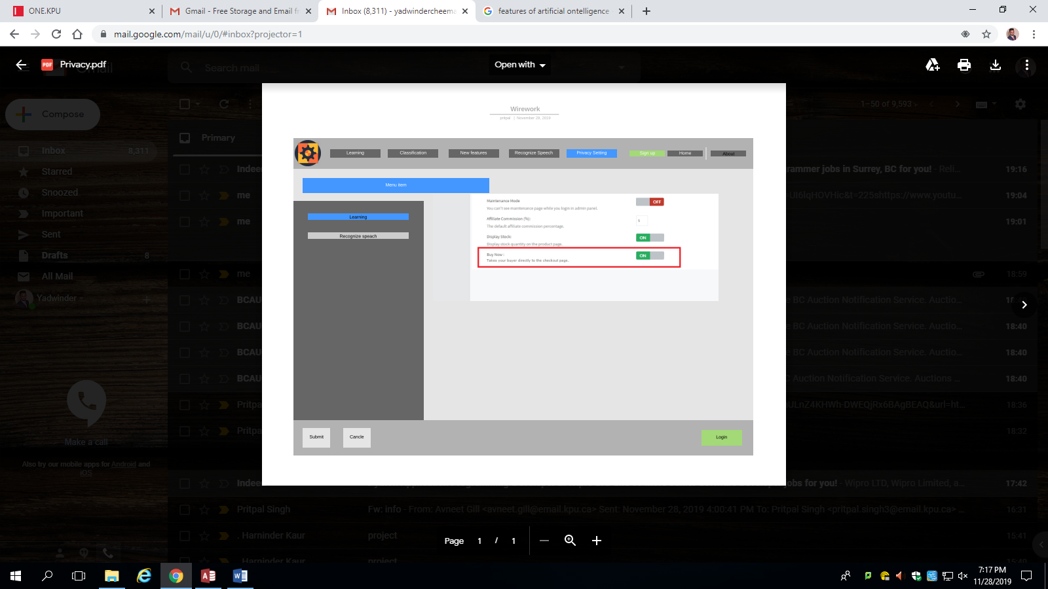

**New Features**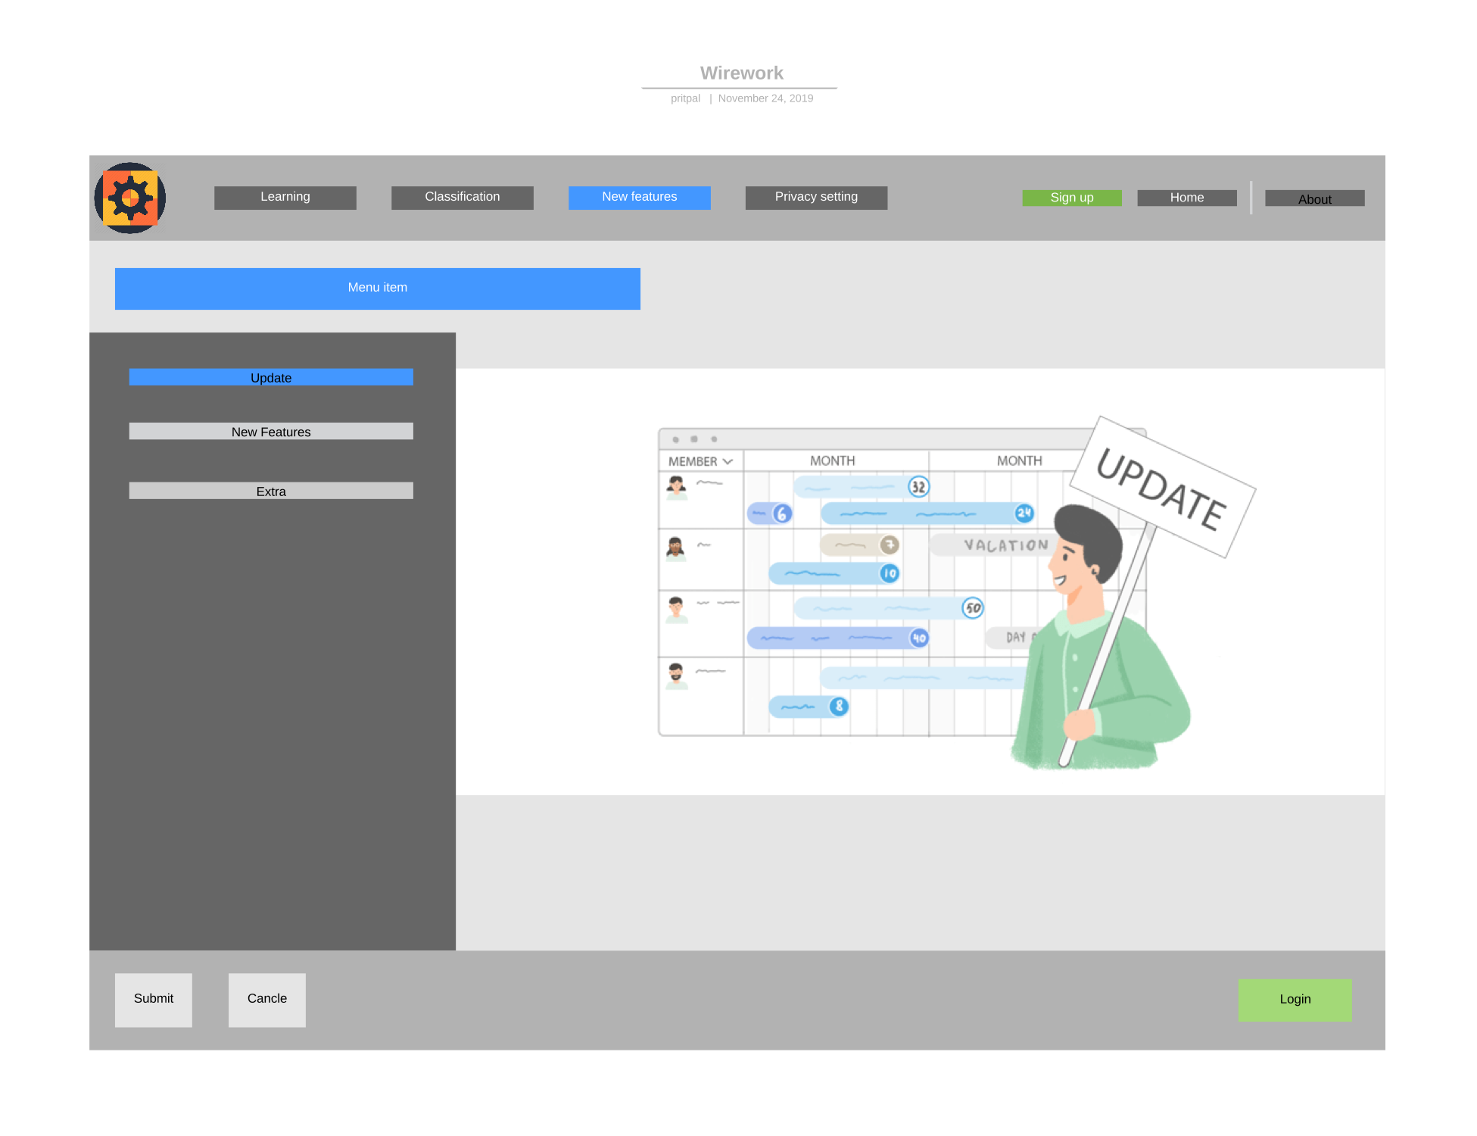

**Classification**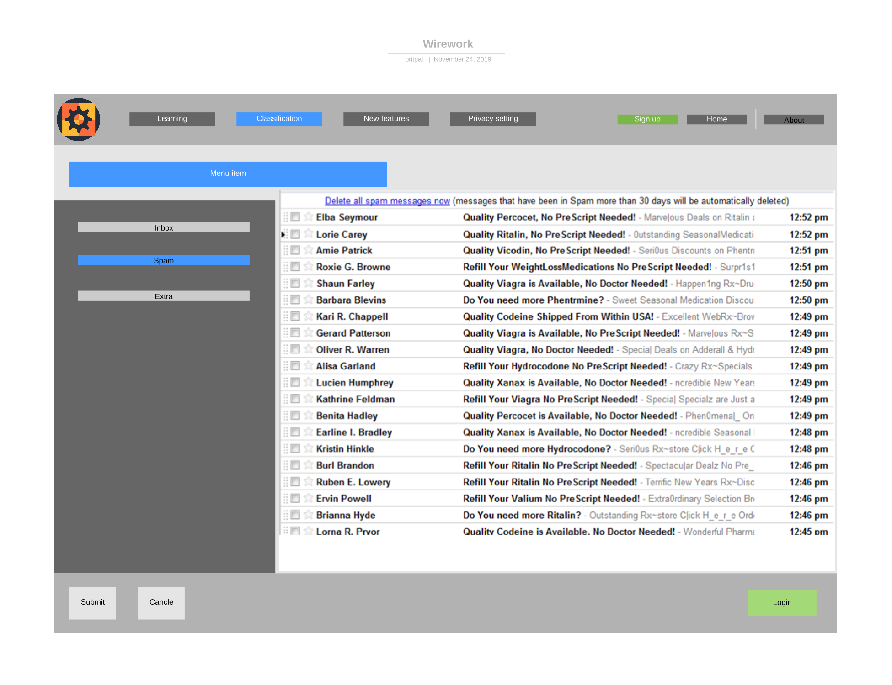

**Learning**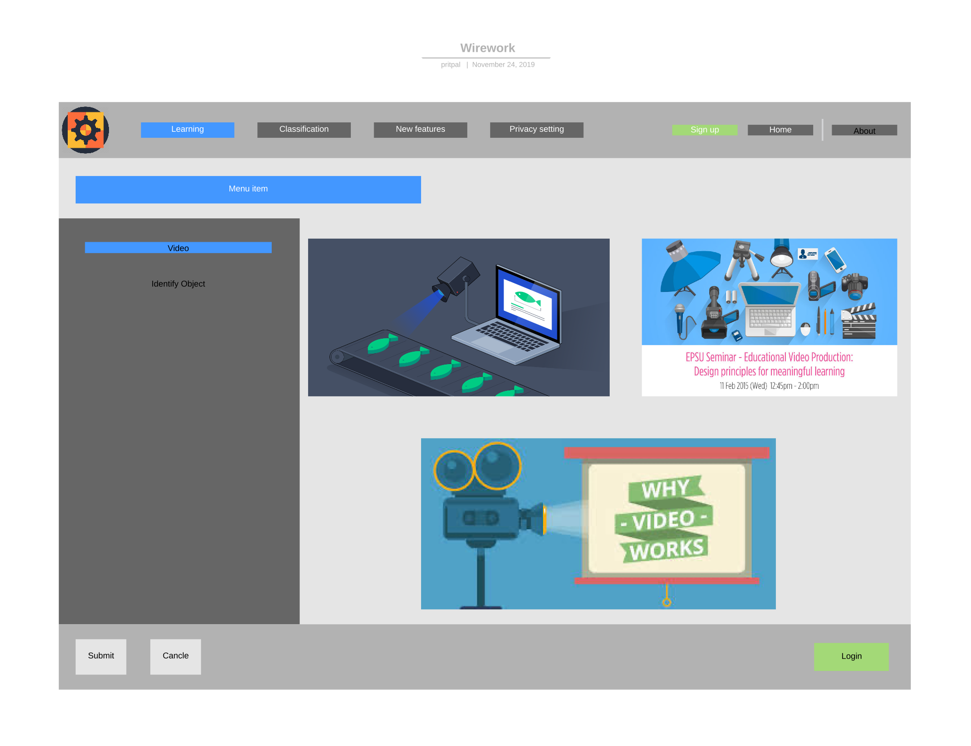

# **9.Access database: -**

Created by: -Yadwinder Singh Cheema

Checked by: -Harninder

## **9.a Tables**

**Add_Features:**

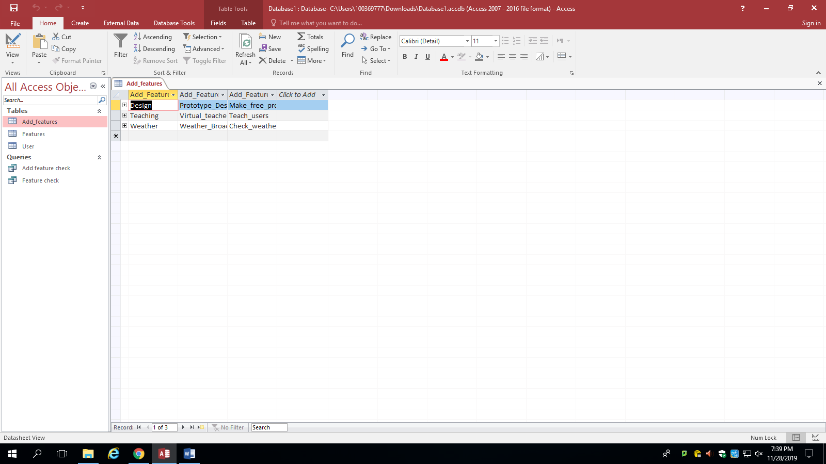

**Features:**

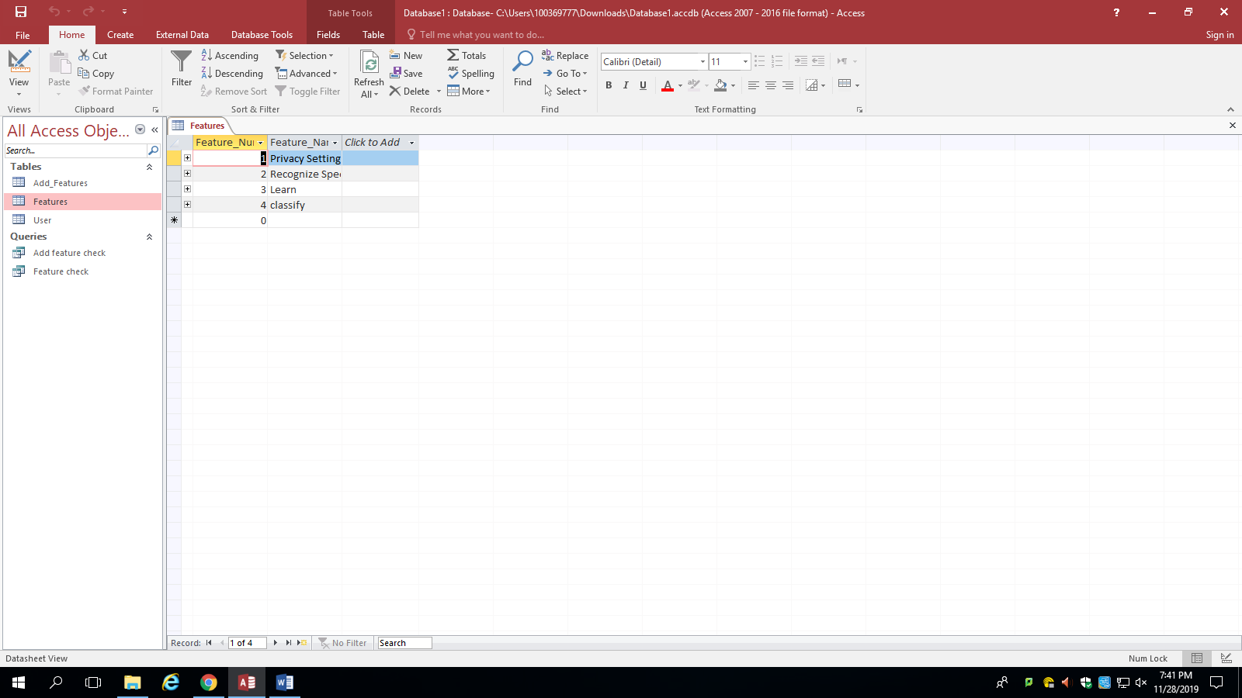

**User:**

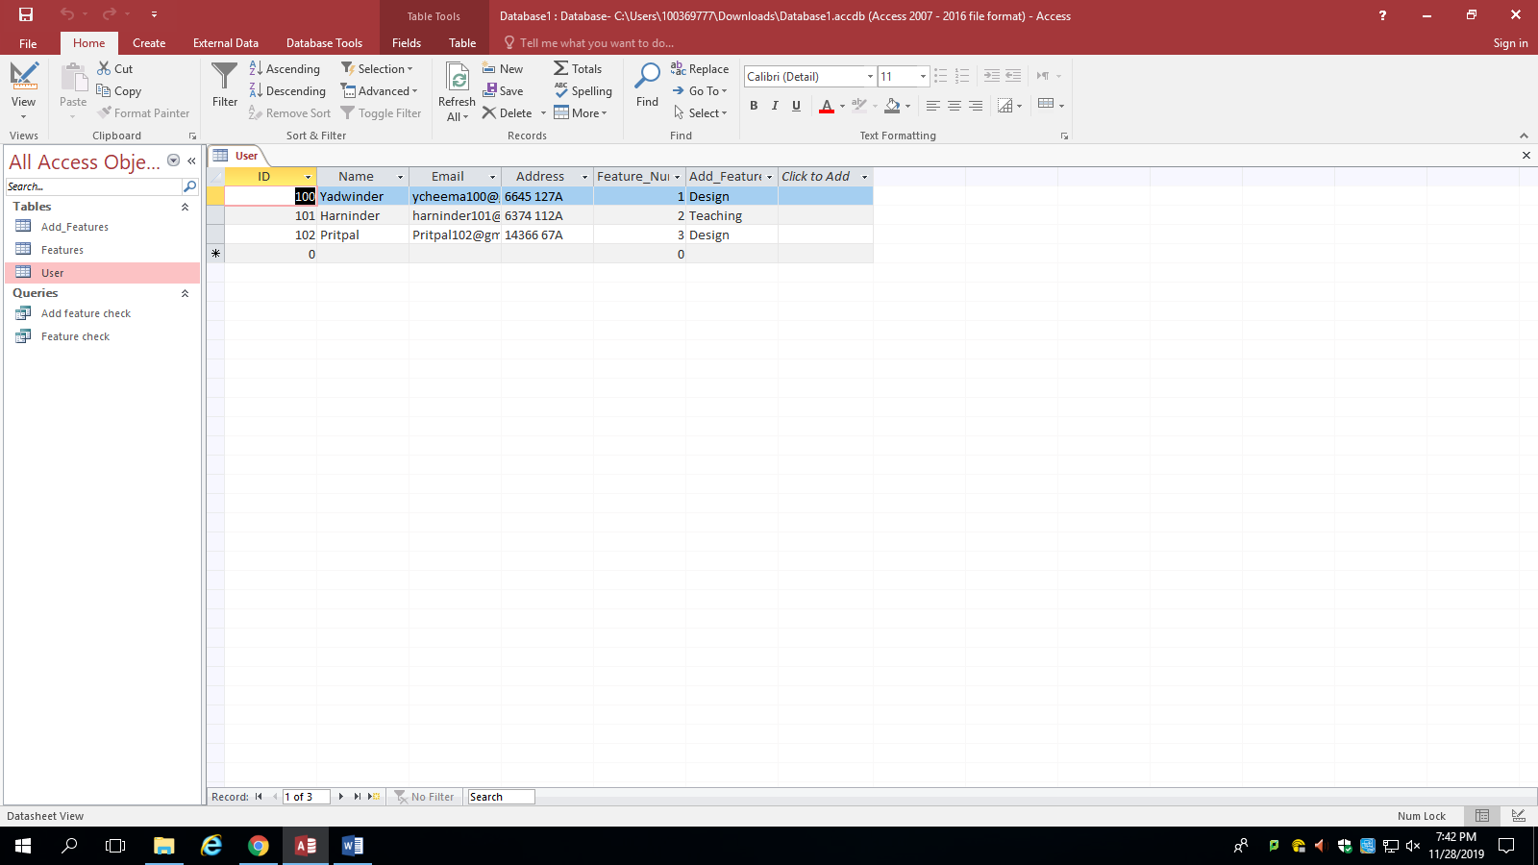

## **9.b Queries:**

**Add feature check:**

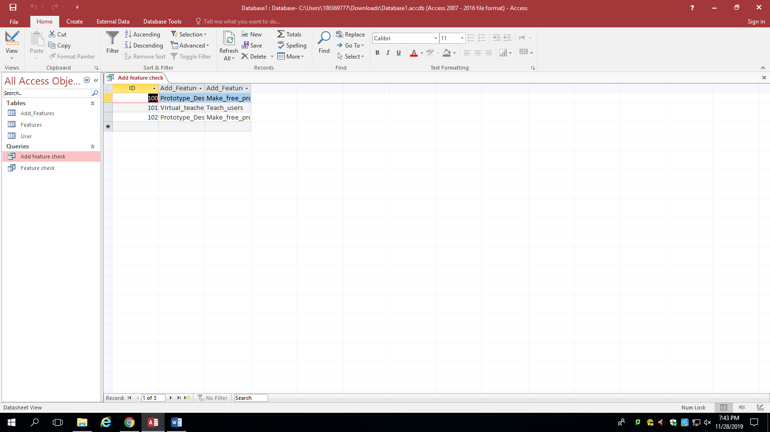

**Feature check:**

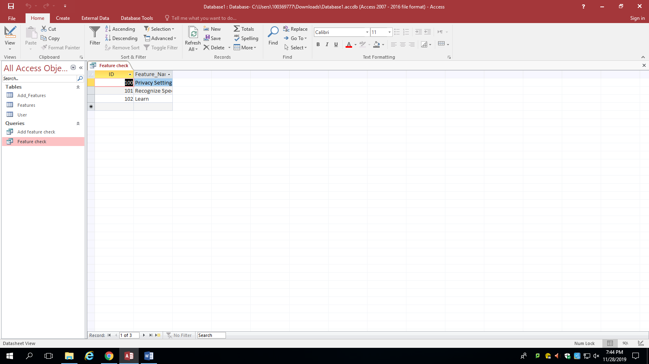

# **10.Trellos link**

[**https://trello.com/b/xDf5DlzU/final-project**](https://trello.com/b/xDf5DlzU/final-project)

# **11.Project Experience**

In our project everything thing worked well except for timing since we were not able to complete some of our give work on time and had to go submit it later. However, this was a fun project which came with a lot of team work efforts, and every team member loved working on this project. Even though, our parts of work were separated but me and my team mates managed to work together and completed every task sooner or later.

**Every member experience: -**

**Yadwinder:**

From this project we learned a lot and had different experiences regarding different topics we are going to cover in our near future at our jobs. This was a skill developing project and we participated in all tasks by understanding their uses and applications.

**Harninder:**

I have learnt and explored my experience on this group project. I really learned a lot about teamwork, communication and the importance of making and sticking to a plan. Sharing and discussing different ideas and amount of knowledge amongst the group also gave me a brief insight on how to deal with problems and come up with an applicable solution. I also experienced how to confront difficulties in a team work and how to resolve any sort of argument or problem and come up with something which is agreeable by everyone.

**Pritpal:**

I learned a lot from this project. We use many tools such as sequence diagram, use case diagram, use case description and interface prototype which going to help us in future. This was a group project, so we learn how to organize and divide task to complete the project on time.

# **12.Conclusion**

To conclude, this application will allow users to use automated technologies like machine learning, artificial intelligence and system security. Moreover, users will be able to do fun tasks while completing their goals as it is going to be both time saving and easy activity to use this application.

# 

# **13.Work Cited**

<https://www.youtube.com/watch?v=pCK6prSq8aw>

<https://www.youtube.com/watch?v=UI6lqHOVHic&t=225s>

<https://www.youtube.com/watch?v=zid-MVo7M-E&t=455s>

<https://www.tutorialspoint.com/uml/uml_use_case_diagram.htm>

<https://www.visual-paradigm.com/guide/use-case/what-is-use-case-specification/>

<https://www.google.com/url?sa=i&source=images&cd=&ved=2ahUKEwiSq7CJsY7mAhULnZ4KHWh-DWEQjRx6BAgBEAQ&url=http%3A%2F%2Fsupport.kartrocket.com%2Fknowledgebase%2F246%2FHow-to-Enable-or-Disable-andsharp039Buy-Nowandsharp039-button-on-Product-Page.html&psig=AOvVaw1aKbpZ4nL3BVaFcAYSR1-w&ust=1575081259864282>

<http://agilemodeling.com/artifacts/uiPrototype.htm>

<https://en.wikipedia.org/wiki/Statistical_classification>

<https://medium.com/datadriveninvestor/classification-algorithms-in-machine-learning-85c0ab65ff4>

<https://www.datarobot.com/wiki/classification/>